Priprema za pisanje druge školske zadaće (pripremni sat)

- pisana vježba – priprema za pisanje proznoga teksta

Tvoj je zadatak napisati tekst trodjelne strukture (uvod, središnji dio, završetak).
Odaberi jedan od ponuđenih naslova: ______________________________________

Ako odabereš kratku priču ili humorističnu priču:
- Odredi gdje će se odvijati radnja tvoje priče. Opiši mjesto odvijanja radnje.
__________________________________________________________________________________________________________________________________________

- Odredi vrijeme odvijanja radnje i koliko radnja traje.
__________________________________________________________________________________________________________________________________________

- Imenuj i opiši likove koji će sudjelovati u tvojoj priči.
_______________________________________________________________________________________________________________________________________________________________________________________________________________
__________________________________________________________________________________________________________________________________________

- Kratko opiši događaj koji pokreće priču.
____________________________________________________________________________________________________________________________________________________________________________________________________________________________________________________________________________________

Ako odabereš životopis, raspravu, osvrt ili problemski članak – prisjeti se njihovih obilježja i strukture.
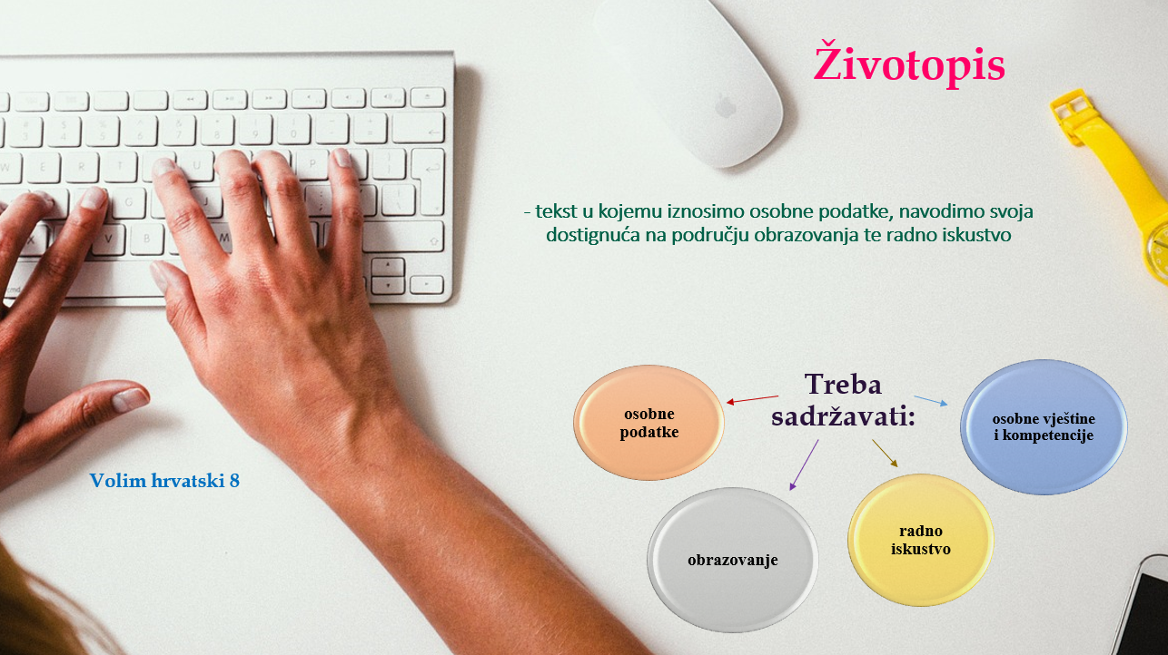
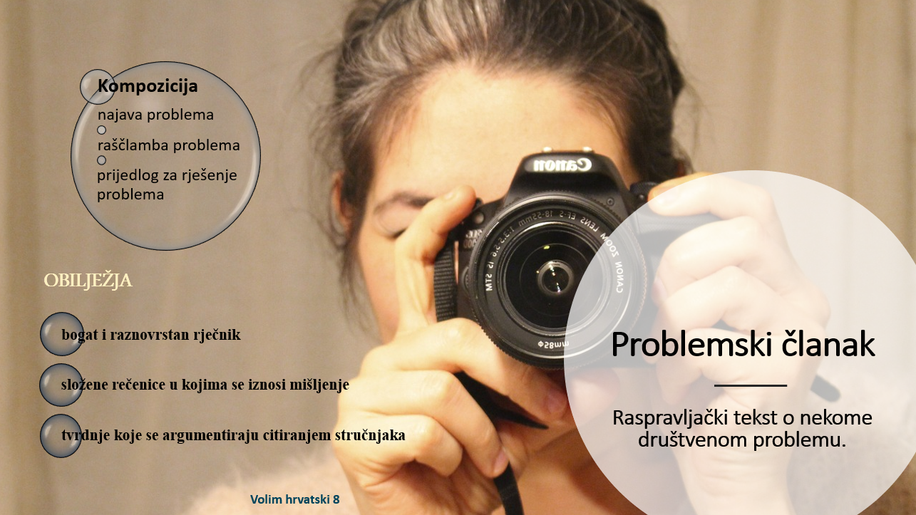
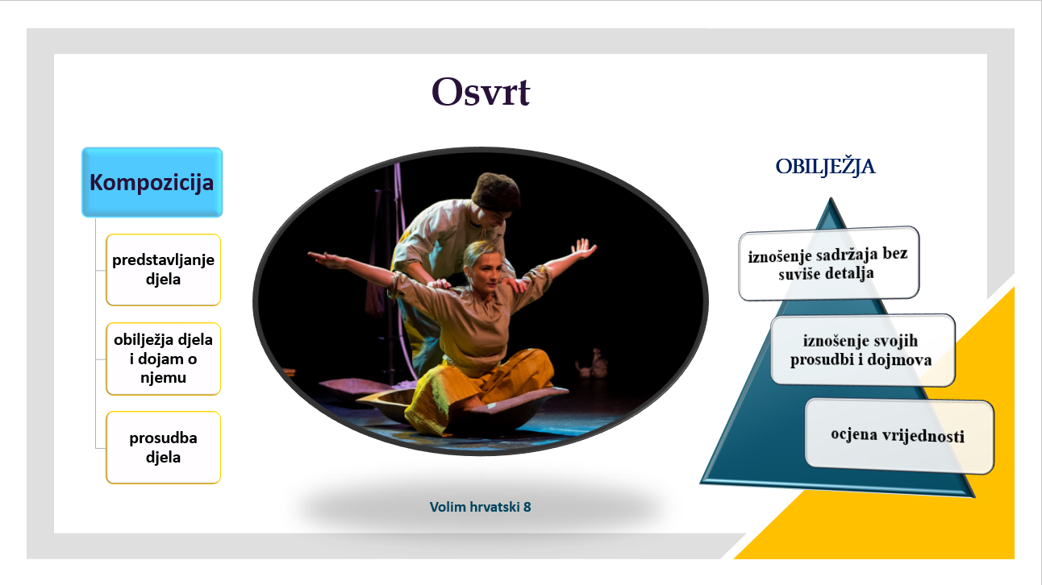
PROBLEMSKI ČLANAK
OSVRT RASPRAVA

____________________________________________
Uvod Uvod
_________________________________________________________________________________________________________________________________________________________________________________________________________________________________

Središnji dio Razrada
____________________________________________________________________________________________________________________________________________________________________________________________________________________________________________________________________________________________________________

Završetak Zaključak
_________________________________________________________________________________________________________________________________________________________________________________________________________________________________

Pisanje
Koristeći se svojim bilješkama napiši priču na poleđini ovoga papira.
Ne zaboravi oblikovati odlomke: uvod, središnji i završni dio sastavka.
_________________________________________________
______________________________________________________________________________________________________________________________________________________________________________________________________________________________________________________________________________________________________________________________________________________________________________________________________________________________________________________________________________________________________________________________________________________________________________________________________________________________________________________________________________________________________________________________________________________________________________________________________________________________________________________________________________________________________________________________________________________________________________________________________________________________________________________________________________________________________________________________________________________________________________________________________________________________________________________________________________________________________________________________________________________________________________________________________

Uređivanje sastavka
Provjeri jesi sve napisao kako si i zamislio, jesu li sva imena i prve riječi u rečenici napisani velikim početnim slovom, je li sastavak smislen i razumljiv, jesu li rečenice povezane, jesu li sve riječi napisane pravopisno i gramatički točno, jesu li vidljivi odlomci te ima li sastavak dobar naslov.
Doradi tekst prema potrebi te ga napiši u zadaćnicu.

